8.20 电子时钟VHDL程序与仿真
1. 10进制计数器设计与仿真
（1）10进制计数器VHDL程序
--文件名：counter10.vhd。
--功能：10进制计数器，有进位C
--最后修改日期：2004.3.20
library IEEE;
use IEEE.STD_LOGIC_1164.ALL;
use IEEE.STD_LOGIC_ARITH.ALL;
use IEEE.STD_LOGIC_UNSIGNED.ALL;
entity counter10 is
Port ( clk : in std_logic;
reset : in std_logic;
din : in std_logic_vector(3 downto 0);
dout : out std_logic_vector(3 downto 0);
c:out std_logic);
end counter10;
architecture Behavioral of counter10 is
signal count : std_logic_vector(3 downto 0);
begin
dout <= count;
process(clk,reset,din)
begin
if reset='0'then
count <= din ;
c<='0';
elsif rising_edge(clk) then
if count = "1001" then
count <= "0000";
c<='1';
else
count <= count+1;
c<='0';
end if;
end if;
end process;
end Behavioral;
- 10进制计数器仿真
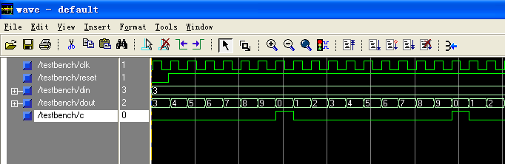
2. 6进制计数器设计与仿真
（1）6进制计数器VHDL程序
--文件名：counter6.vhd。
--功能：6进制计数器，有进位C
--最后修改日期：2004.3.20
library IEEE;
use IEEE.STD_LOGIC_1164.ALL;
use IEEE.STD_LOGIC_ARITH.ALL;
use IEEE.STD_LOGIC_UNSIGNED.ALL;
entity counter6 is
Port ( clk : in std_logic;
reset : in std_logic;
din : in std_logic_vector(2 downto 0);
dout : out std_logic_vector(2 downto 0);
c:out std_logic);
end counter6;
architecture Behavioral of counter6 is
signal count : std_logic_vector(2 downto 0);
begin
dout <= count;
process(clk,reset,din)
begin
if reset= '0' then
count <= din;
c<='0';
elsif rising_edge(clk) then
if count="101" then
count<="000";
c<='1';
else
count<=count+1;
c<='0';
end if;
end if;
end process;
end Behavioral;
（2）6进制计数器仿真
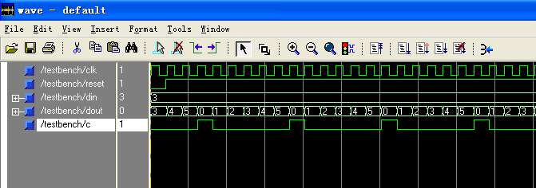
3. 6进制计数器设计与仿真
（1）24进制计数器VHDL程序
--文件名：counter24.vhd。
--功能：24进制计数器。
--最后修改日期：2004.3.20
library IEEE;
use IEEE.STD_LOGIC_1164.ALL;
use IEEE.STD_LOGIC_ARITH.ALL;
use IEEE.STD_LOGIC_UNSIGNED.ALL;
entity counter24 is
Port ( clk : in std_logic;
reset : in std_logic;
din : in std_logic_vector(5 downto 0);
dout : out std_logic_vector(5 downto 0));
end counter24;
architecture Behavioral of counter24 is
signal count : std_logic_vector(5 downto 0);
begin
dout <= count;
process(clk,reset,din)
begin
if reset= '0' then
count <= din;
elsif rising_edge(clk) then
if count(3 downto 0)="1001" then
count(3 downto 0)<="0000";
count(5 downto 4)<=count(5 downto 4) +1;
else
count(3 downto 0)<=count(3 downto 0)+1;
end if;
if count="100011" then
count<="000000";
end if;
end if;
end process;
end Behavioral;
（2）24进制计数器仿真
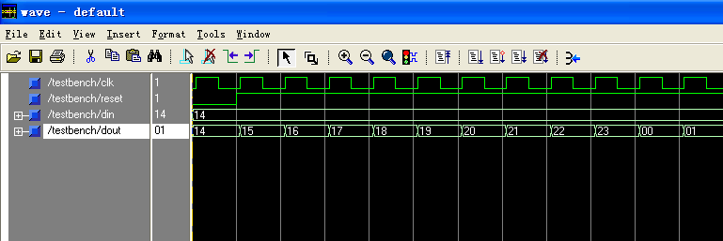
4. 译码器设计
（1）译码器VHDL程序
--文件名：decoder.vhd。
--功能：将4bit二进制数译码，在LED上显示相应数字。
--最后修改日期：2004.3.20
library IEEE;
use IEEE.STD_LOGIC_1164.ALL;
use IEEE.STD_LOGIC_ARITH.ALL;
use IEEE.STD_LOGIC_UNSIGNED.ALL;
entity decoder is
Port (din:in std_logic_vector(3 downto 0 ); --四位二进制码输入
dout:out std_logic_vector(6 downto 0) ); --输出LED七段码
end decoder;
architecture Behavioral of decoder is
begin
process(din)
begin
case din is
when "0000" => dout<="0000001";--0
when "0001" => dout<="1001111";--1
when "0010" => dout<="0010010";--2
when "0011" => dout<="0000110";--3
when "0100" => dout<="1001100"; --4
when "0101" => dout<="0100100";--5
when "0110" => dout<="0100000";--6
when "0111" => dout<="0001111";--7
when "1000" => dout<="0000000";--8
when "1001" => dout<="0000100";--9
when others => dout<="1111111";
end case;
end process;
end Behavioral;
5. 顶层设计与仿真
（1）顶层设计VHDL程序
--文件名：clock.vhd。
--功能：时钟的顶层设计。
--最后修改日期：2004.3.20
library IEEE;
use IEEE.STD_LOGIC_1164.ALL;
use IEEE.STD_LOGIC_ARITH.ALL;
use IEEE.STD_LOGIC_UNSIGNED.ALL;
entity clock is
Port ( clk : in std_logic; --1Hz
reset : in std_logic; --复位信号
dins : in std_logic_vector(6 downto 0);--秒钟预置
dinm : in std_logic_vector(6 downto 0);--分钟预置
dinh : in std_logic_vector(5 downto 0);--时钟预置
secondl: out std_logic_vector(6 downto 0);--秒钟低位输出
secondh: out std_logic_vector(6 downto 0); --秒钟高位输出
minutel: out std_logic_vector(6 downto 0); --分钟低位输出
minuteh: out std_logic_vector(6 downto 0); --分钟高位输出
hourl: out std_logic_vector(6 downto 0); --小时低位输出
hourh: out std_logic_vector(6 downto 0)); --小时高位输出
end clock;
architecture Behavioral of clock is
component counter10 is
Port ( clk : in std_logic;
reset : in std_logic;
din : in std_logic_vector(3 downto 0);
dout : out std_logic_vector(3 downto 0);
c:out std_logic);
end component;

component counter6 is
Port ( clk : in std_logic;
reset : in std_logic;
din : in std_logic_vector(2 downto 0);
dout : out std_logic_vector(2 downto 0);
c:out std_logic);
end component;

component counter24 is
Port ( clk : in std_logic;
reset : in std_logic;
din : in std_logic_vector(5 downto 0);
dout : out std_logic_vector(5 downto 0));
end component;

component decoder is
Port (din:in std_logic_vector(3 downto 0 );
dout:out std_logic_vector(6 downto 0));
end component;

signal c1,c2,c3,c4:std_logic;
signal doutsl,doutml:std_logic_vector(3 downto 0);
signal doutsh,doutmh:std_logic_vector(2 downto 0);
signal douth:std_logic_vector(5 downto 0);
signal rdoutsh,rdoutmh:std_logic_vector(3 downto 0);
signal rdouth:std_logic_vector(7 downto 0);
begin
rdoutsh <= '0'&doutsh; --将秒钟高位数据变为4位，再进行译码
rdoutmh <= '0'&doutmh; --将分钟高位数据变为4位，再进行译码
rdouth <="00"&douth; --将时钟高位数据变为4位，再进行译码
u1: counter10 port map( clk=>clk,reset=>reset,
din=>dins(3 downto 0),
dout=>doutsl,
c=>c1);
u2: counter6 port map( clk=>c1,reset=>reset,
din=>dins(6 downto 4),
dout=>doutsh,
c=>c2);
u3: counter10 port map( clk=>c2,reset=>reset,
din=>dinm(3 downto 0),
dout=>doutml,
c=>c3);
u4: counter6 port map( clk=>c3,reset=>reset,
din=>dinm(6 downto 4),
dout=>doutmh,
c=>c4);
u5: counter24 port map( clk=>c4,reset=>reset,
din=>dinh,
dout=>douth);
u6: decoder port map( din => doutsl,dout => secondl); --秒的低位
u7: decoder port map( din => rdoutsh,dout => secondh); --秒的高位
u8: decoder port map( din => doutml,dout => minutel); --分的低位
u9: decoder port map( din => rdoutmh,dout => minuteh); --分的高位
u10: decoder port map( din => rdouth(3 downto 0),dout => hourh);--时的低位
u11: decoder port map( din => rdouth(7 downto 4),dout => hourl);--时的高位
end Behavioral;
（2）顶层设计仿真
